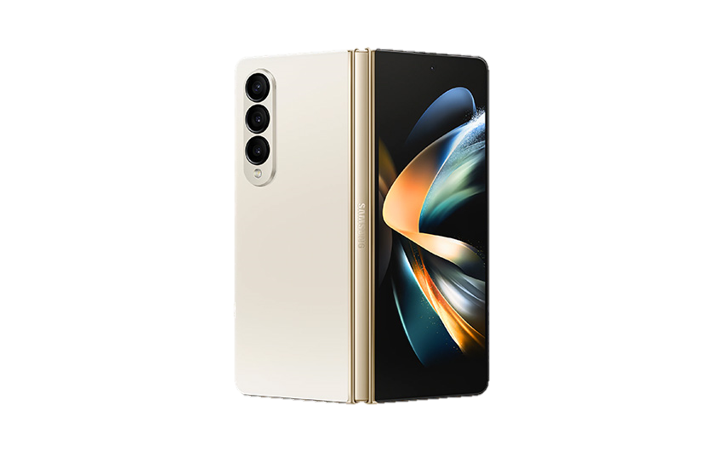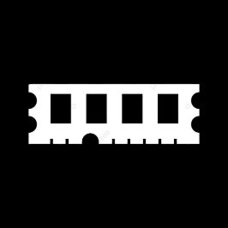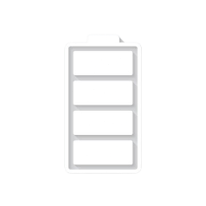

Price: [$ 524.94](https://m.gsmarena.com/samsung_galaxy_z_fold4-price-11737.php) $715

* GALAXY FOLD 4
* Processor: Qualcomm SM8475 Snapdragon 8+ Gen 1 (4 nm)
* Front Camera:4 MP
* Rear Camera:50 MP
* Display:7.6 “
* NFC:Yes:
* Colors: Graygreen, Phantom Black, Beige, Burgundy
* Operating System:

Android 12L

* Charging Type:USB Type-C
* SIM: Nano-SIM and eSIM
* Fingerprint:Yes
* Release Date: 2024,
* September 09

RAM

12

GB

ROM

01

TB

BATTERY

4400

mAh



+001-28272300-2466-2469



webmaster@cellinfo.com



A-65, ACME Co. ,

Street No. 12,

New York

Ask Me Ltd.